

Midterm Project Report

Advanced Computer Programming

Student Name : Chintsogt
Student ID : 113021194
Teacher : DINH-TRUNG VU

2024-04
Introduction 1
1.1 Github 1
1.2 Overview 1
Implementation 2
2.1 Class 1 - RepositoryData 2
2.1.1 Fields 2
2.1.2 Methods 2
2.1.3 Functions 2
2.2 Class 2 - GithubSpider (Scrapy Spider) 2
2.2.1 Fields 2
2.2.2 Methods 2
2.3 Method/Function 1: Parse 3
2.4 Method/Function 2: run command 3
Results 4
Result 1 4
Result 2 4
Conclusions 5

Introduction

1.1 Github
- Personal Github Account: https://github.com/Chintsogt0825
- Group Project Repository: https://github.com/Chintsogt0825/Midterm

1.2 Overview
In this project, I built a GitHub scraper using the Scrapy framework in Python. The program extracts information such as the repository name, description (About), repository URL, and placeholders for commits, languages, and last updated time from a personal GitHub profile page.
The key Python features and libraries used include:
- @dataclass for structuring repository data
- Scrapy for structured crawling
- pprint for formatted output
- CSS selectors for HTML parsing
- String manipulation functions (e.g., strip())
The results show structured JSON-style outputs of each repository, successfully scraped from my GitHub account.

Implementation

2.1 Class 1 - RepositoryData
A data class to represent information extracted from each GitHub repository.

2.1.1 Fields
name: Name of the repository
about: Short description of the repository
commits: Placeholder for number of commits
languages: Placeholder for programming languages used
last_updated: Placeholder for last updated time
url: Repository URL

2.1.2 Methods
__init__: Initializes the data fields
__repr__: (Optional) Custom string representation for display

2.1.3 Functions
Used mainly for data holding, so only built-in methods.

2.2 Class 2 - GithubSpider (Scrapy Spider)
A Scrapy class that inherits from scrapy.Spider.

2.2.1 Fields
name: Identifier for the spider (“github”)
allowed_domains: Restricts crawl to GitHub domain
start_urls: URL of the GitHub user profile with repository listings

2.2.2 Methods
parse(self, response): Main method that extracts repository info using CSS selectors.

2.3 Method/Function 1: Parse
This is the Scrapy callback that handles the HTTP response from GitHub and parses repository data.
Process:
- Select all repository list items
- Extract repository name and URL
Extract the description (if available)
- Yield dictionary-like object representing each repository

2.4 Method/Function 2: run command
scrapy crawl github

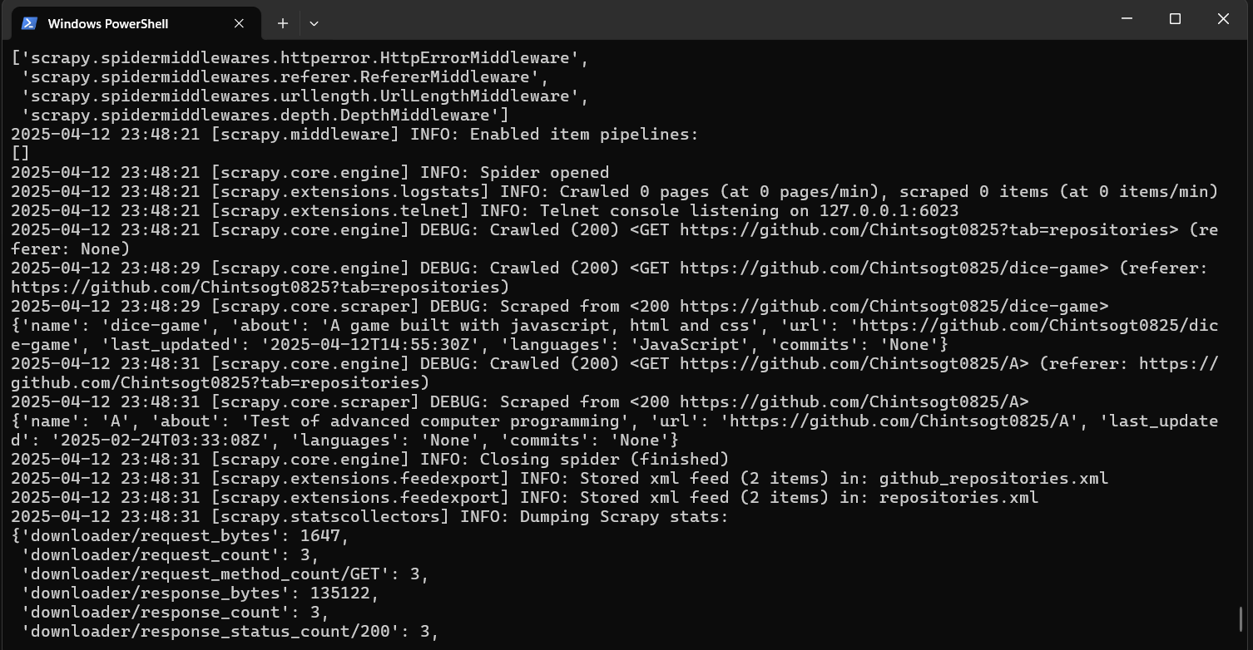

Results

Result 1
.2025-04-12 23:48:29 [scrapy.core.scraper] DEBUG: Scraped from <200 https://github.com/Chintsogt0825/dice-game>
{
'name': 'dice-game',
'about': 'A game built with javascript, html and css',
'url': 'https://github.com/Chintsogt0825/dice-game ',
'last_updated': '2025-04-12T14:55:30Z',
'languages': 'JavaScript',
'commits': 'None'
}

Result 2
2025-04-12 23:48:31 [scrapy.core.scraper] DEBUG: Scraped from <200 https://github.com/Chintsogt0825/A>
{
'name': 'A',
'about': 'Test of advanced computer programming',
'url': 'https://github.com/Chintsogt0825/A',
'last_updated': '2025-02-24T03:33:08Z',
'languages': 'None',
'commits': 'None'
}

And they are stored in "C:\Users\chint\Documents\github_scraper\github_scraper\github_repositories.xml"

Conclusions
This project demonstrates the power of Scrapy in extracting structured data from a web page. Using advanced Python features like @dataclass and formatted output with pprint, I was able to extract and display useful metadata from my GitHub profile.
While this version focused on basic information (name, about, and URL), it can be extended further to include:
- Number of commits (by crawling deeper into each repository)
- Languages used (via GitHub language bars or API)
- Last updated times (also via deeper page crawling)
Overall, this project helped reinforce my understanding of Python web scraping, HTML parsing, and data organization using object-oriented programming.

